Programming Paradigms Mark Scheme

- (a) <VARIABLE NAME>;;=<ALPHA>|<ALPHA><DIGIT><DIGIT>|<ALPHA><ALPHA>
(1 per alternative, 1 for correct use of notation, max 4)
(4)
(b) <VARIABLE NAME>::=<X>|<Y>
<X>::= <ALPHA>|<ALPHA><X>
<Y>::= <ALPHA><NZD><DIGIT>
<NZD>::= 1l2l3l4l5l6l7l8l9
(2 for definition of X, 1 for definition of Y, 1 for definition of NZD, 1 for two options for variable name, max 4)
(4)

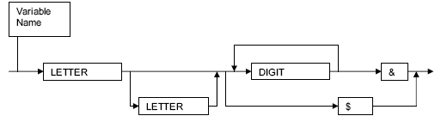
Mark Points:
- Recognisable syntax diagram showing sequence
- Single letter possible
- Two letters, without more, possible
- Single digit possible
- Loop for multiple digits…
- inside $ loop
- Dollar loop correctly positioned to miss Digits and &
- & after digits loop
(1 per -, max 6)
[6]
- (a) <AMOUNTOFMONEY>::=$<INTEGER> / $<INTEGER>.<DIGIT><DIGIT> / $.<DIGIT><DIGIT>
(b) AMOUNTOFMONEY

$ INTEGER . DIGIT DIGIT

Notes: A very simple example of this type of question, but bearing in mind the short amount of time in the examination, this is realistic. The exam question can be made more difficult by having a recursive definition in the Backus Naur question and by having a return loop in the syntax diagram.

